

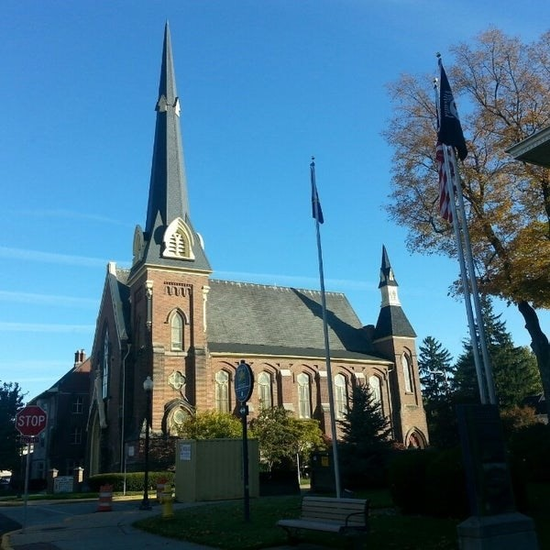
February 4, 2026

A Global Methodist Church
214 S. 5th Street
Goshen, IN 46528
Phone: 574-533-9518
Web Site: goshenfirstgmc.org

Office Hours: Monday-Friday,
8:00 a.m.-12:00 noon
Worship: 9:00 a.m.
Sunday School: 10:30 a.m.
Pastor Jeff & Lisa
Associate Pastor Rich Hull
OUR VISION: “Growing in Faith, Gathering in Community, and Giving in Love”.

The Monday morning Bible study has started up again. They meet at 9:30 a.m.
in the Parlor. They are studying the book of Acts. Everyone is welcome.


The Primetimers will meet on Thursday, February 19, at 11:30 a.m. for lunch in the Garden Room. We will have a soup and salad lunch for $12. After lunch, we will
listen to our special speaker, Andrew Priem, who is an EMT in Goshen. Everyone is welcome! Please let Betty Jo Morris know if you plan to come.



VOLUNTEERS – Thank you for your service! Sunday morning, February 8
Greeters: Gary & Diane Miller VIP: Cathy Smith
Elevator Hosts: Ted & Shirley Fairfield
Ushers: Erv Herschberger, Sharon Hull, Ken Smith, Dan Becker, Steve Warner
Scripture Reader: Ken Smith
Elementary Junior Church: Rachel Parsons Tenorio, Kelley Leeper
Junior High Church: Linda Russell
Coffee Hour: Gary & Pat Huber
Bus Driver: Steve Warner

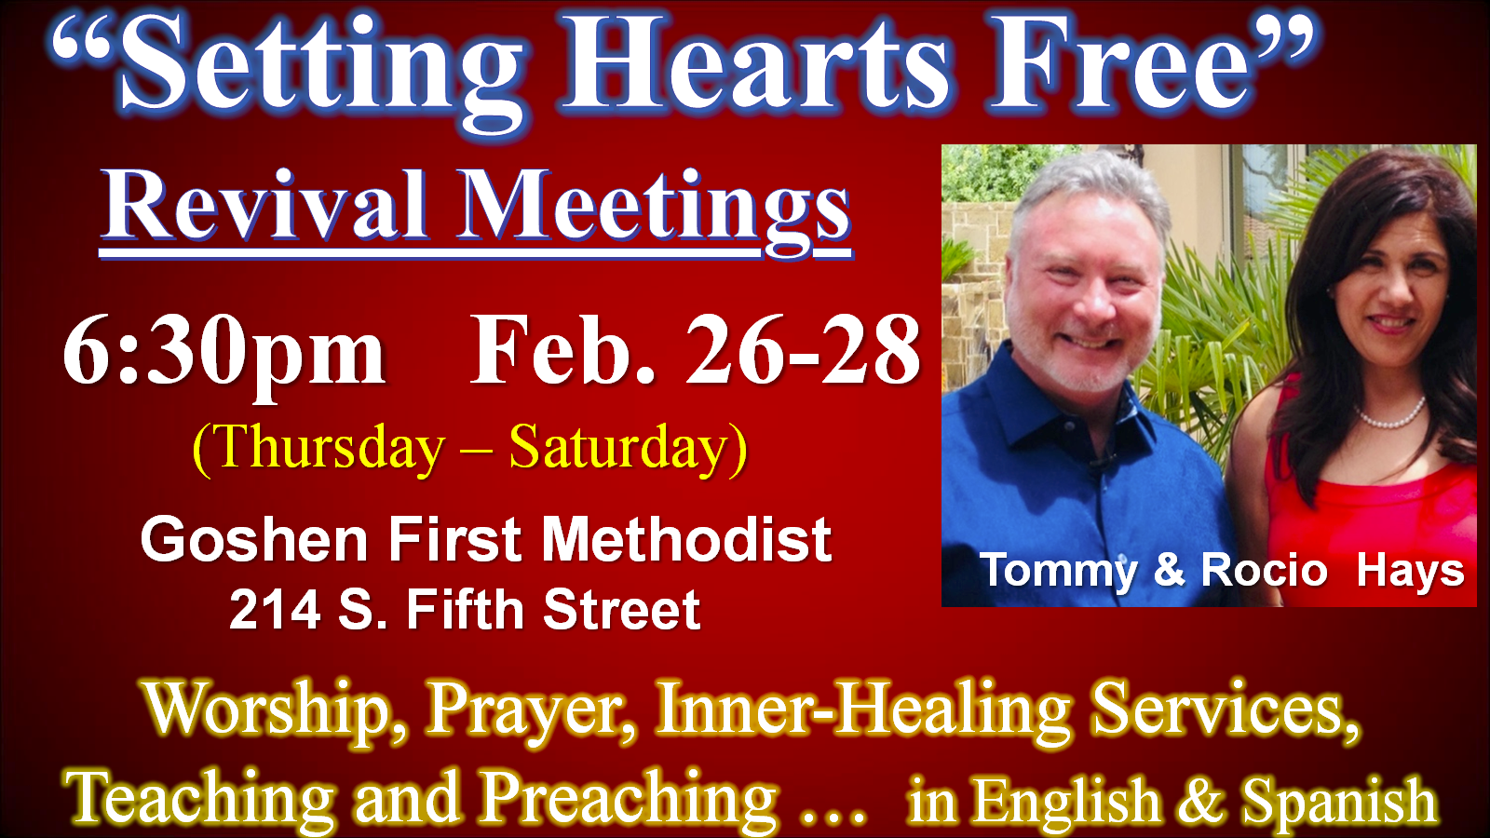

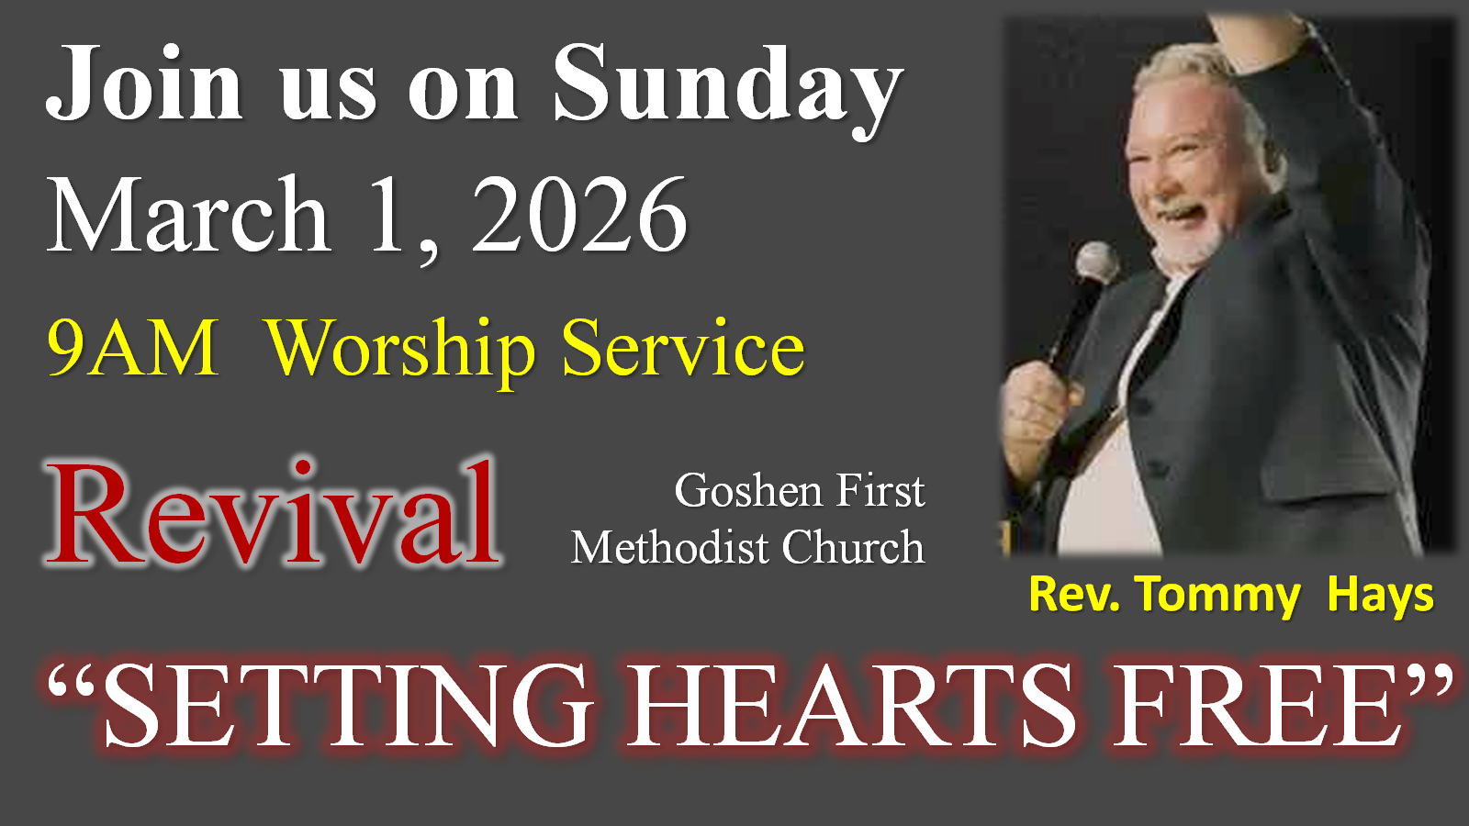

We are in need of a bus driver for Sunday mornings to help pick up some of our members. You would drive on a rotating basis with the other drivers. Please let Harriet at the church office know if you can help.

The Wednesday evening meal and classes continue. The meal is at 5:30 p.m., and classes are at 6:00 p.m. Pastor Jeff will lead a book study, “Victory Over the Darkness” by Neil Anderson. The children meet for class, and child care is provided for preschoolers. The Grief Share class will start up on March 4 and will continue until May 27. Everyone is welcome.

CHURCH CALENDAR – FEBRUARY
MONDAYS
9:30 a.m. – Bible Study – for men and women
10:45 a.m. – Exercise (PIYO)
6:00 p.m. - Handbells

TUESDAYS
9:00-9:45 a.m. – Exercise class (Shred 60)
6:00 p.m. – Prayer at church (first and third Tuesdays)
5:30-6:00 p.m. – Exercise class (High Intensity Interval Training)

WEDNESDAYS
10:00 a.m. – Painting class
3:00 p.m. – Church Council (February 11)
5:30 p.m. – Meal
6:00 p.m. – Classes
6:30 p.m. - Ash Wednesday service (February 18)
7:00 p.m. – Choir practice

THURSDAYS
9:00-9:45 a.m. – Exercise class (Shred 60)
12:00-1:00 p.m. – Men’s Brown Bag Lunch (every week)
11:30 a.m – Primetimers (February 19)
5:30-6:00 p.m. – Exercise class (High Intensity Interval Training)
6:30 p.m. – Revival meeting (February 26)
FRIDAYS
6:30 p.m. – Revival meeting (February 27)
SATURDAYS
5:30-10:00 p.m. – Contra Dance (first Saturday night – February 7)
6:30 p.m. – Revival meeting (February 28)
SUNDAYS
9:00 a.m. – Worship
9:00 a.m. – Revival meeting (March 1)
10:30 a.m. – Sunday School
4:00 p.m. – “The Edge”

